Arrival and parking facilities

MESSE RIED, Brucknerstraße 39, A - 4910 Ried im Innkreis

Arrival by car:
From Passau / Wels / Linz / Graz
- Drive on the highway A8 (Innkreisautobahn) up to the exit Ried im Innkreis
- Carry on towards Ried im Innkreis
- Follow the tradeshow signage
From Salzburg / Innsbruck / Klagenfurt
- auf de Drive on the highway A1 direction Vienna up to the exit Wallersee
- Carry on towards Straßwalchen
- Carry on towards Friedburg
- Carry on towards Schneegattern
- Carry on towards Ried im Innkreis
- Follow the tradeshow signage
Ample parking areas are available at the fairgrounds.
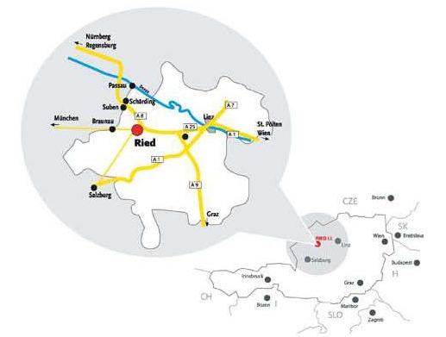

Arrival by train
From the central station “Ried im Innkreis” it is a 15 minutes’ walk to the Rieder Messe. Furthermore, the train stop “Bad Ried" (only regional trains) is right next to the fairgrounds.

